Test Data Used

Customer number - 0009055766

Username - 018cb93b26d79a7b

Password - 759ff668cc93a4c0f25e2a

Start Up Screen to enter credentials

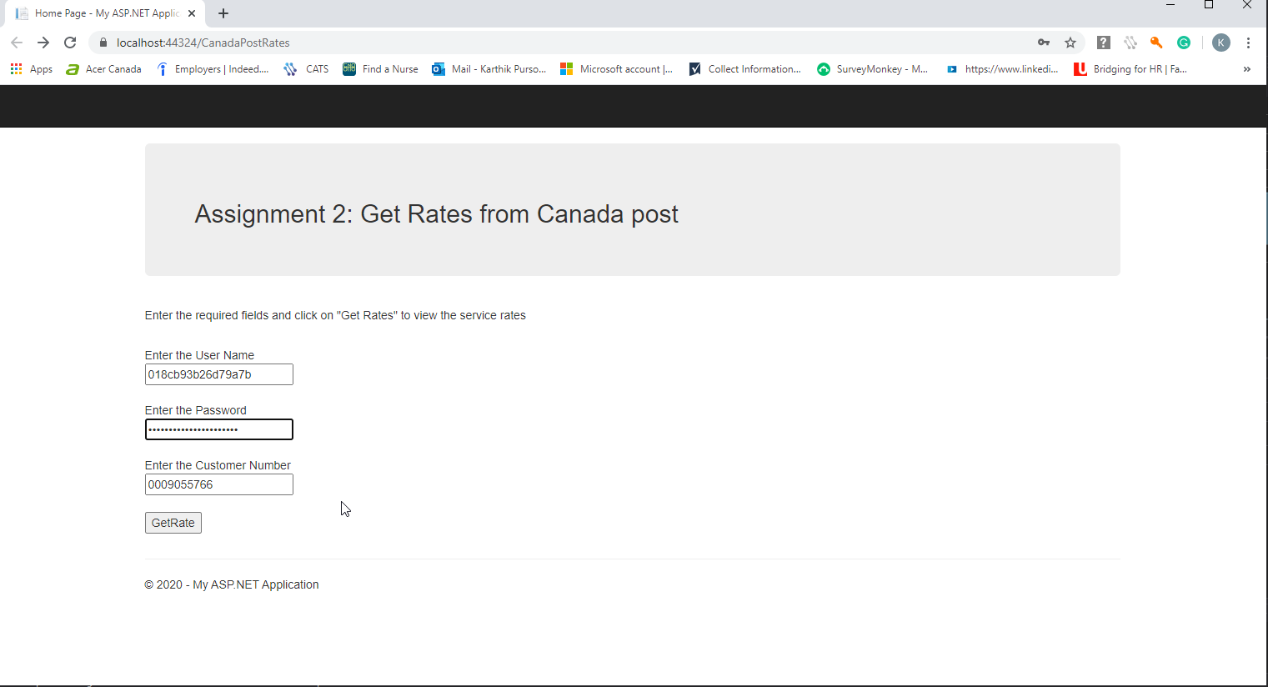

On clicking Get Rate the rate table is displayed

